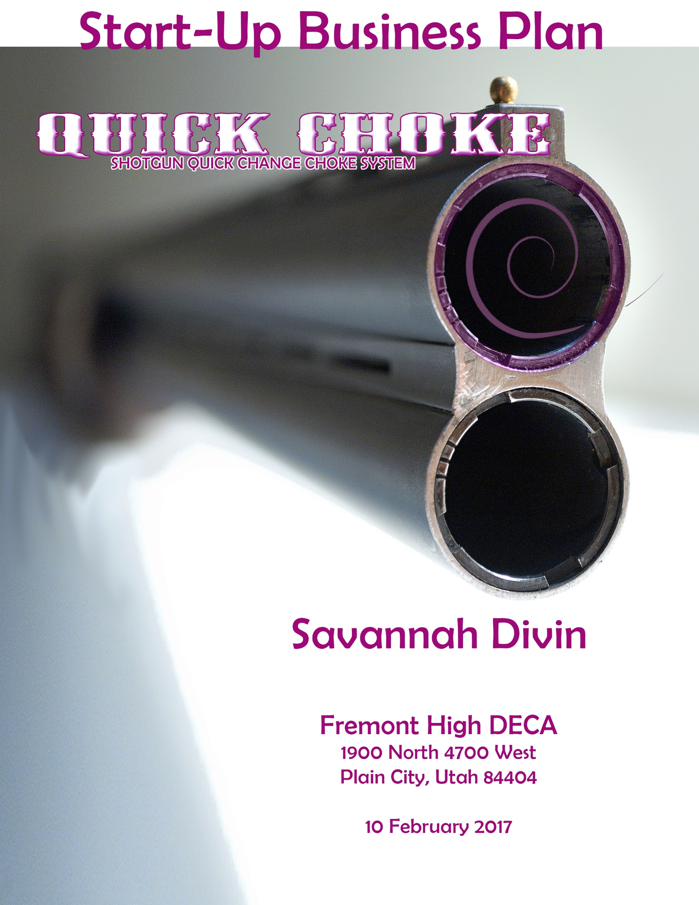

Table of Contents

I. EXECUTIVE SUMMARY 1

II. PROBLEM 2

II. CUSTOMER SEGMENTS 3

IV. UNIQUE VALUE PROPOSITION 3

V. SOLUTIONS 4

VI. CHANNELS 5

VII. REVENUE STREAMS 5

VIII. COST STRUCTURE 8

IX. KEY METRICS 9

X. COMPETITIVE ADVANTAGE 9

XI. CONCLUSION 10

XII. BIBLIOGRAPHY 10

# I. EXECUTIVE SUMMARY

The average shooter will spend astounding $9.9 billion annually on their sport.

### The Market

The QuickChoke, modified choke, will be a money and time consumer. Making a gun choke go on nice and smooth saving time.

### QuickChoke

The QuickChoke, will only require 360 Degree turn and the choke will be nice and snug onto the shotgun. QuickChoke only has 12 threads on the choke making it twist on faster compared to another choke that has 32. Including your investment today you will receive gun grease and oil with your purchase. Having a little bit of weight at the end of your shotguns barrel will make a big difference in the world. It will help improve your shooting scores and make competing better and more fun!

### Money

This is a cost efficient and will be the most durable purchase you would ever make. We are asking for a loan of 90,000.00 7% interest and will all be paid over the course of 8 years. Over the course of 5 years we have projected into making 21,429.73 dollars. This choke will cost from the range of $45.00-85.00.

### Competitors

Some of my competitors will not believe what my product can offer shooters. This will be a time saving choke. I will be located in Ogden, Utah in my store and will have chokes in outdoor recreational outlets. My store will include a different variety of chokes and will have anything you need for cleaning materials for your guns.

# II. PROBLEM

The problems with using modified gun chokes on a shot gun is that it requires a good amount of time to successfully have the choke tightened and twisted on. Also remembering what size the right size choke is. Most of the time having a variety of different size chokes they tend to get lost easily. While using a gun choke for multiple of times the threads tend to strip and no longer want to hold a grip and stay tightly in the shot gun.

While shooting most chokes are a lightweight piece. Which does not benefit you with keeping the gun at the right direction while holding the gun up to your shoulder making it so you can look right down the barrel of the gun. As well as purchasing a gun chokes tend to get expensive.

# II. CUSTOMER SEGMENTS

With this new and improved gun choke my product of the choke will be social media based. I will have a website, Facebook and pop up ads. My Target market is for all trap shooters that are male or female. Their age range can be from 15-72 with the mid age range of teens and the low of older people.

The gun choke will be located in all major outfitter stores thought the U.S such as Cabela’s, Sportsman Warehouse, Recreation Outlet, and on the web through Amazon and EBay.

This new choke will be optional for all trap shooters that are involved with ATA, AIM and shooters that are attending shooting events at gun clubs. This choke will be used every time a shooter is putting together their gun for a shooting event.

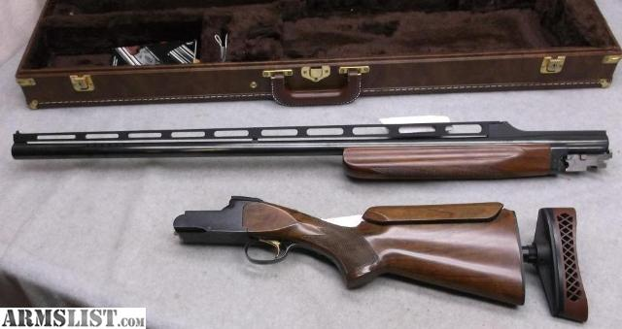

# IV. UNIQUE VALUE PROPOSITION

Having a modified gun choke will be a speed time consuming process. Normal regular gun chokes have 36 threads having to use the chug to twist 12 times around until the choke in nicely secured onto the gun. Then having to worry about your choke coming loose. With the modified gun chokes you have 12 threats that will only take a 360 Degree turn until the gun choke is then tightly secured onto the gun saving you 60 seconds in time and not having to worry about the choke come uptight on the line.

# V. SOLUTIONS

This gun choke is the best of the best when it comes time to change the choke or putting together the gun. The modified gun choke will only require 12 threads and a quick 360 degrees to have the gun choke nice and secure on the gun, instead of a normal gun choke that has 36 threads and you have to twist 8 times clock wise just to make this choke nice and tight on the gun. While the shooter is out on the line they will not have to worry about the choke coming loose.

Having a choke that a shooter uses multiple times taking the choke on and off the treads tend to break. With this new modified choke that problem will never happen to you. The reason is because the less threads you have require the less tuning with this choke we have 12 threads and just a 360 degree turn making it so the treads will not wear as fast as a normal choke.

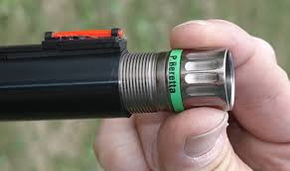 Then when it comes time to change or insert the modified choke remember what choke is what can get confusing. With this product the different chokes will be different colors so you can remember what size is what and insert the wrong choke. Most gun chokes get lost when you have a variety of chokes that why when you purchase a gun choke now you will receive a pouch, grease and oil in your purchase. This product is more affordable than most.

Light weight chokes can be a pain sometimes. With this new choke it will be a little heavier than most because with the weight being added at the end of the barrel it will help the shooter keep the gun pointed down with shooting a clay target and make the shooter a better shot.

# Image result for upsVI. CHANNELS

The modified gun choke will be manufactured in Ogden, Utah. All major outfitter stores such as Cabela’s, Sportsman’s warehouse, Browning Outlet and a Recreation Outlet will carry the modified gun chokes. Also on the web through Amazon and EBay. If purchasing though the web shipping will be delivered through UPS, USPS, or FedEx.

# VII. REVENUE STREAMS

## Revenue Model

### Production model

In the production model, the business that creates the product or service sells it to customers who value and thus pay for it. This is the most common revenue model and a possible example would be a company that produces paper, sells it to either the direct public or other businesses who pay for the paper thus generate revenue for the paper company.

### E-tail

E-tail is a form of retail. Retail is the process of selling consumer goods and/or services directly to end-consumers to earn a profit. Demand is created through promotion, and by satisfying consumers' wants and needs effectively (which generates word-of-mouth-advertising).

In the 21st century, an increasing amount of retailing is e-tailing, done online using electronic payment and delivery via a courier or postal mail. Via e-tail, the customer can shop and order through the internet and the merchandise is dropped at the customer's doorstep. This format is ideal for customers who do not want to travel to retail stores and are interested in home shopping.

The online retailer may handle the merchandize directly, or use the drop shipping technique in which they accept the payment for the product but the customer receives the product directly from the manufacturer or a wholesaler.

## Lifetime Values

We believe that when a customer purchases a choke and realizes how nice and easy it was that they will fall in love with it. Then while they are out competing in a shooting event other shooter will notice how awesome that choke is and how easy and quick it was to insert the choke. Because this is such a revolutionary product customers will be encourage to recommend it to friends and gain a sense of loyalty to our company.

## Revenue

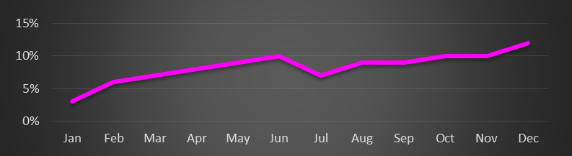

## Gross Margins

# VIII. COST STRUCTURE

## Customer Acquisition Costs

The customer acquisition cost is going to be around $45.00-85.00. In your purchase this will include an extra choke, will come with a case, gun grease and oil. This choke will be partnering with the browning company.

## Distribution Costs

Shipping and handling will be charged to a costumer who decides to purchase a choke online instead of stores. If a carrier of the store is out of this product the costumer will not have to pay for shipping and it will automatically be sent to their house with no charge.

## Projected Expenses



# IX. KEY METRICS

Modified chokes will be throughout Ogden, Utah. We will participate in trade shows such as the Salt Lake Hunting expo that they have every year. Anything in Ogden we will be there. Our logo will be on billboards, pop up ads and on social media through Facebook and twitter. There will be YouTube of how easy the choke is to go on and off. We are soon working on into combing with Browning and hopefully make new products together. Or if Browning decides to buy me out right to own my company if it is a reasonable offer it will be a good done deal.

# X. COMPETITIVE ADVANTAGE

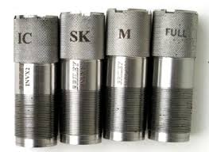One thing about having a product of a gun choke is there is a ton of different varieties and brands of chokes that I will competing with. A price difference will play a major factor in this but the quality and the time consuming of this will win the buyer over. The weight in the choke that will allow the shooter to have a little bit of weight at the end of their barrel will benefit them. Some hunters will not believe in the modified choke and would want to look in to a standard, supper full, and an improved cylinder.

# XI. CONCLUSION

The modified choke will be marked to all shooters in the age range from 15-72 years old that are living in the United States. Making QuickChoke a new fast and money saving choke. My advertising campaign will be all through Facebook, twitter, Instagram, pop up ads, on billboards and YouTube videos. I will be asking for a $90,000 with a 7% interest. Having everything paid off in 8 years. The cost of my gun choke will be from the range of $45.00-85.00. QuickChoke will be a new product that customers won’t be able to live without!

# XII. BIBLIOGRAPHY

<http://www.cabelas.com/category/Shotgun-Chokes-Accessories/104202180.uts>

<https://www.google.com/searchsalt+lake+hunting+expo>

<http://1source.basspro.com/index.php>