Fabric File
Name | Type | Information | Sample | Characteristics | Uses | Care Of
Acetate | Manufactured/  Synthetic Fiber | The second oldest manufactured fiber in the U.S. after rayon, acetate was first used in France as an airplane wing varnish and later developed as a fiber in the U.K. in 1923. Developed for use as a fabric in the U.S. in 1924, acetate could not be mass-produced until chemists solved the problems with dyeing the fabric.  Acetate fabrics are made with spun filaments of cellulose taken from wood pulp. Classified as a chemical fiber textile or semi-synthetic, acetate is sometimes mixed with silk, wool or cotton to make it stronger. Acetate flakes are generated by a reaction of the wood pulp to a variety of acetic acids. The flakes are dissolved in a solvent, and then passed through a spinneret -- as the solvent evaporates -- to create the filaments used to construct the acetate fabric. | 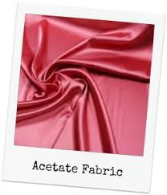  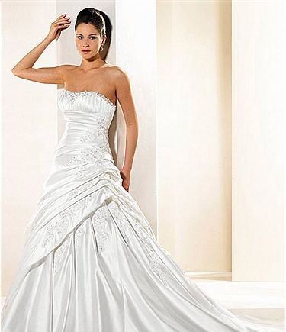 | - Drapes and hangs well  - Multiple sheens and color options  - Quick drying fabric that resists shrinking  - Moth and mildew resistant  - Low static  - High luster, elegant appearance and feel  - Fabric doesn't pill. | - Apparel: Blouses, linings, wedding and party attire, home furnishings, draperies  - Industrial Uses: Cigarette filters  - High Absorbency Products: Diapers & Surgical Products  Award Ribbons  Original Lego Bricks – 1949-1963 | - Dry-cleaning is best  - Hand wash in warm water with mild suds.  - Do not twist or wring out garment.  - Do not soak colored items.  - Press while damp on wrong side with cool iron.  - For finishing on the right side, use a pressing cloth

