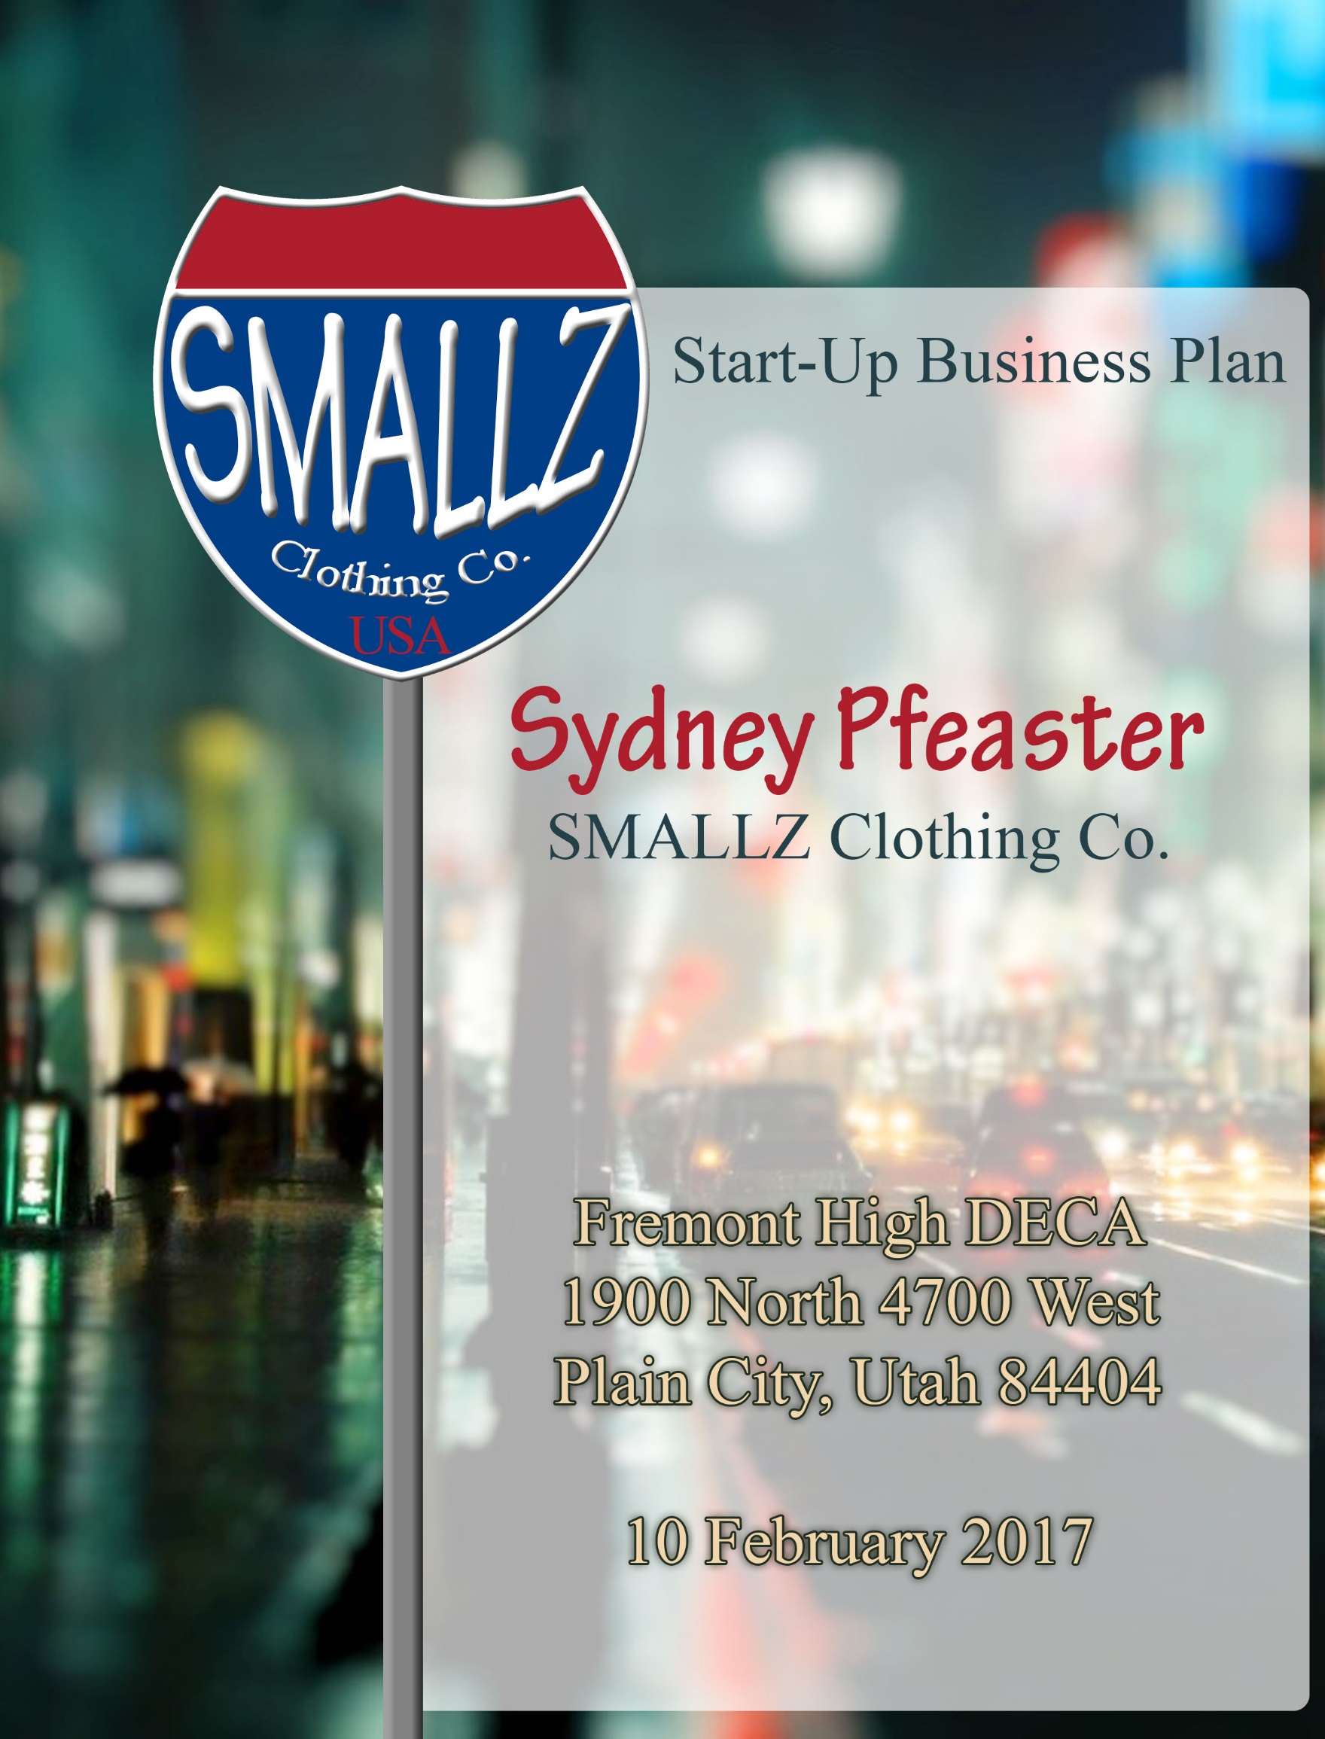

# Table of Contents

I. EXECUTIVE SUMMARY 1

II. PROBLEM 2

III. CUSTOMER SEGMENTS 3

IV. UNIQUE VALUE PROPOSITION 4

V. SOLUTIONS 5

VI. CHANNELS 5

VII. REVENUE STREAMS 6

VIII. COST STRUCTURE 9

IX. KEY METRICS 10

X. COMPETITIVE ADVANTAGE 10

XI. CONCLUSION 11

XII. BIBLIOGRAPHY 11

XIII. APPENDIX 11

# I. EXECUTIVE SUMMARY

Smalls is a clothing company which designs and sells clothes specifically made for short and small women of all ages. There are so many women around the world who struggle to find clothes that fit flatteringly and comfortably without emphasizing the fact that they are short and thin. Smalls is able to solve this problem by designing clothes in small sizes and lengths in upcoming/modern fashions found today.

This may mean the clothes will be sized equivalent to that of kid sized shirts or pants, but the designs and styles of the clothes will match the age of the person accordingly. Smalls will cater to ages ranging from 16 to 30 years old, and will come in varying prices to satisfy all social classes of women. Smalls has a variety of departments, prices, and quality; to appeal to as many people as possible and to attract as many customers as we can.

Smalls also offers “Custom Smalls” which allows for customers to find a product in the store or online (made by Smalls) and have Smalls size the clothing to fit perfectly to the customers’ body. This way the clothes will indefinitely fit the customer and allow Smalls more profit and better sales and customer service. With the online features, the customer can use the 3D virtual picture to see what they would look like in the clothes they want to buy on the Smalls website.

Smalls is hoping to make around $200,000 profit in the 5th year with very little loss in the company in the means of finances. Smalls is asking for $300,000 loan for 30% equity in the company. The $300,000 is a result of the start-up costs and what Smalls figured it would take in order to build the company up to where it needs to be in order to earn a profit.

# II. PROBLEM

### Problem 1:

Many women around the world are confronted with the struggle of finding clothes that fit them comfortably and flatteringly, especially if they are short or skinny. Either their pants are too long, or there too big around the waist and thighs. Then shirts are even worse; they can be too baggy to be worn in public and long enough to come down past the knees. Having clothes that fit can either make or break a woman’s confidence.

### Problem 2:

Often times petite size clothes are very expensive despite the actual quality. It is usually cheaper to buy regular clothes and figure out a way to make it work then to buy new petite clothes for nearly twice as much money.

### Problem 3:

Even when certain stores have a petite section, they never have petite clothes in different departments of clothes. An example would be a clothing store that has a total of two racks in the petite section and they only have a few pairs of jeans, a couple of t-shirts, and a few casual dresses. This leaves smaller women stuck with wearing oversized workout clothes, work clothes, and even most of their casual clothes will be too big.

# III. CUSTOMER SEGMENTS

**In 2014, sixty percent of the population was 5’4” or shorter.**

**-- livestrong.com**

### Overview

The target market for Smalls is women ages 16-30 who are shorter and smaller than average who struggle to find clothes that fit them properly. Smalls clothes will vary in quality which will appeal to all social classes here in the U.S.

### Demographic

Women

Ages 16-30

Under 5’4” in height

### Psychographic

All social classes from mid-to-high-end buyers.

### Behavioral

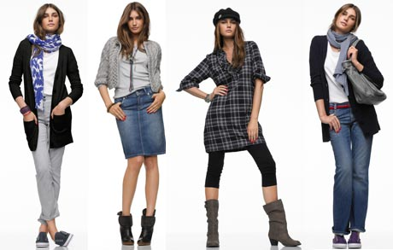Women who seek to feel comfortable and beautiful in their outfits without worrying that their clothes won’t fit

# IV. UNIQUE VALUE PROPOSITION

Smalls will be much like any other clothing/department store with junior’s and women’s sections. The size of the store will be similar to that of Justice or H&M, but Smalls will be unique in the way that it will carry petite sizes in age appropriate designs and styles. Women who are short and small often have problems finding clothes that fit them flatteringly and comfortably. The stores will have a huge variety in the clothes they sell such as departments, styles, patterns and prices.

The one thing that will stay consistent however is the sizes. The sizes will be made for short and small women and even though the clothes are kid sized they will be in modern adult styles and trends. Another feature Smalls offers is custom clothing; if a customer brings a product to the check-out counter that still doesn’t fit their body just right, Smalls will send the piece of clothing as well as the customers’ measurements back to the manufacturer where the piece will be hemmed and redone so it will fit the customer perfectly. This can be done with little to no cost depending on the amount of work needed to be done.

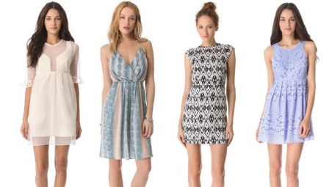These reasons are what will make Smalls different from other companies, and as of right now there is no direct competition. Smalls gives the opportunity for small women to shop for clothes they know are going to fit them at a variety of prices, several departments, and a wide range of petite sizes so no matter the woman’s size, they will be able to find something that fits.

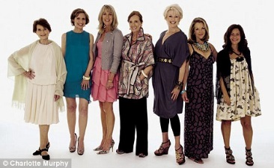

# V. SOLUTIONS

### Solution 1:

Smalls will carry a wide variety of petite women’s clothing that will leave women feeling beautiful and confident in their own bodies. The sizes are all focused around petite sizes; the smallest shirt size will be a 12 in kids’ sizes (but the clothes will be in adult styles and designs), the largest shirt size will be a medium in women’s sizes. The pants will follow the same lines, so the smallest size will be a 12 in kids’ sizes and the biggest will be a 5 in adult sizes.

### Solution 2:

In order for Smalls to appeal to as many people as possible, the clothes in the store will vary in quality allowing for prices to be varied. This will make it so nearly all social classes can shop here and they won’t have to break their wallet to get clothes that will fit them.

### Solution 3:

To give customers the best variety and the best options when shopping for small clothes, Smalls will have a wide range if departments where women can find clothes in, such as: athletic, work/business, casual, and dressy. This way customers have a lot of options to choose from and they are forced to settle with clothes they don’t like.

# VI. CHANNELS

Smalls Designers

Manufacturers

Customers

Stores

# VII. REVENUE STREAMS

## Revenue Models

### Advertising Model

  
Social Media

-Facebook

-Instagram

-Snapchat

[](http://www.bing.com/images/search?q=billboards&view=detailv2&&id=439CA872F66843F88F8FA520EBB9A19DF307B074&selectedIndex=2&ccid=/mpGLA4d&simid=608006897553442361&thid=OIP.Mfe6a462c0e1dc0931e5e755db95bd6c3o0)Radio

Billboards

-major roads and freeways around Utah

Apps

-Ads on games and other apps

### Licensing model

Smalls will license the measurements, designs, and styles of their clothing. There will also be a copyright of the name of the business.

### Production model

Step 1: Clothes are designed and sized

Step 2: Designs are sent to manufacturers and made

Step 3: Clothes are distributed to stores using trucks

Step 4: Stores then sell the clothes to the customers

## Lifetime Values

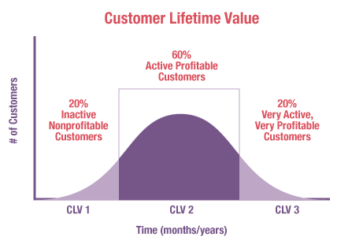

crowdale.com

Average Order Value: **$69.99**

Repeat Purchase Rate: **4**

Customer Acquistion Cost: $**16**

Estimated Customer Lifetime Value: **$139.98**

## Projected Revenue



At the end of Smalls third year, the total profit will be about $2,600, but will continue to increase each year as sales increase. The end of our 5th year in business, the company will be making about $47,000 net profit with an estimated $467,000 in sales.

# VIII. COST STRUCTURE

## Projected Expenses

## Distribution Costs

Since Smalls will be manufacturing most of their own clothes there will be very little distribution costs which is the cost of using trucks to bring the clothes from the manufacturers to each one of the stores. The startup distribution costs will be assumed by the customer as an add-on to any order.

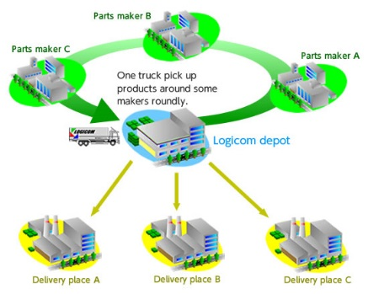

# IX. KEY METRICS

* 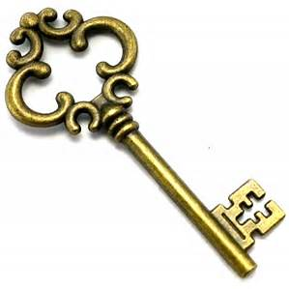Actual Sales: Regularly and when Smalls have sales/discounts and clearance items sold.
* Licensing/patents
* Total Expenses
* Estimated Sales Revenue
* Start-up costs
* Target Market

# X. COMPETITIVE ADVANTAGE

No other store offers adult styles and designs in kids sized clothing. Smalls will also have an entire store of petite size clothing, while many stores only have as much as one rack in their entire store for petite women.

*Patents

*Licensing

*Business security

# XI. CONCLUSION

Smalls is a clothing company that designs and sells clothes specifically made for short and small women of all ages. There are so many women around the world who struggle to find clothes that fit flatteringly and comfortably without emphasizing the fact that they are short and thin. Smalls is able to solve this problem by designing small sizes and lengths in upcoming/modern fashions found today. Smalls is hoping to make around $200,000 profit in the 5th year with very little loss in the company in the means of finances.

We are asking $300,000 for 30% in the company. The $300,000 is a result of the start-up costs and what Smalls figured it would take in order to build the company up to where it needs to be in order to earn a profit.

# XII. BIBLIOGRAPHY

http://www.howmuchisit.org/semi-truck-cost/

http://www.investopedia.com/terms/m/metrics.asp

http://www.investopedia.com/terms/m/metrics.asp

http://www.forentrepreneurs.com/startup-killer/

http://www.livestrong.com/article/357769-weight-height-for-the-average-american-woman/

# XIII. APPENDIX

[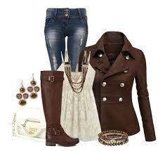](http://www.google.com/url?sa=i&rct=j&q=&esrc=s&source=images&cd=&cad=rja&uact=8&ved=0ahUKEwjarKzb1PTRAhUQ4GMKHZajD6YQjRwIBw&url=http://thebestfashionblog.com/womens-fashion/everyday-clothing-ideas-for-women-over-50&bvm=bv.146094739,d.cGc&psig=AFQjCNEh2c9ueScwHBMcef8io1Dr9pBNIw&ust=1486236526669061)[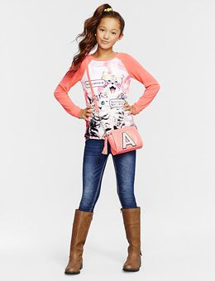](https://www.google.com/url?sa=i&rct=j&q=&esrc=s&source=images&cd=&cad=rja&uact=8&ved=0ahUKEwjv_sao1fTRAhWhgFQKHZ2bCX0QjRwIBw&url=https://www.pinterest.com/explore/tween-girls-clothing/&bvm=bv.146094739,d.dGc&psig=AFQjCNElun5-ksunAFH4qnKPZpEEnRjXpA&ust=1486236634000845)