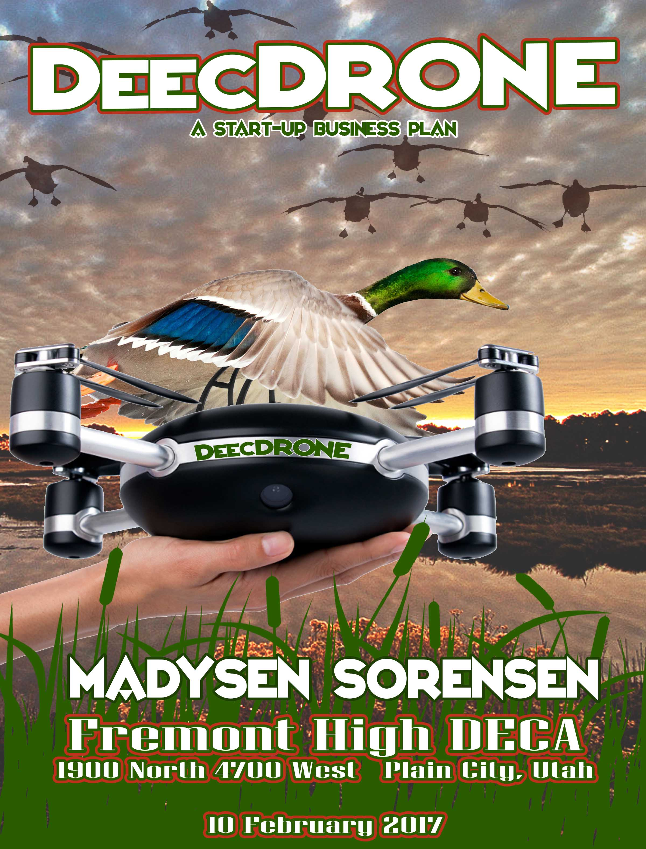

# TABLE OF CONTENTS

I. EXECUTIVE SUMMARY 1

II. PROBLEM 2

III. CUSTOMER SEGMENTS 4

IV. UNIQUE VALUE PROPOSITION 5

V. SOLUTION 5

VI. CHANNELS 6

VII. REVENUE STREAMS 6

VIII. COST STRUCTURE 7

IX. KEY METRICS 9

X. COMPETITIVE ADVANTAGE 9

XI. CONCLUSION 9

XII. BIBLIOGRAPHY 10

XIII. APPENDIX 11

# I. EXECUTIVE SUMMARY

Mission Statement- the DeecDRONE’s mission is to provide hunters all over the world with an up close experience of hunting and to learn more about the different animal species.

Target Market- The target market for the DeecDRONE is basically people between ages 16-60 of both genders, who are avid bird or/and waterfowl hunters.

Secondary Markey- Aside from hunters would be bird researchers.

Potential**-** The potential of the DeecDRONE is outstanding. There is nothing that provides a more modern high-tech hunting experience. There is no competition in this line of product and that will give it the first step in growing potential of a product like this. This product isn’t just a solution it is also an amazing resource for research and is guaranteed to grow nationwide.

The products will include the basic line of Drone Decoys made by DeecDRONE manufacturers. Along with our services will be a kit put together for customers to create their own DeecDRONE with a variety of styles and species of birds. On our website will be instructions and how to videos and a customization tool while placing an order. The personalization tool and ability to make your own kit makes it easier to have a priced variety for all uses of the DeecDRONE. Along with the creation process once purchased a filtered app will let customers share videos and pictures from their experiences with others everywhere.

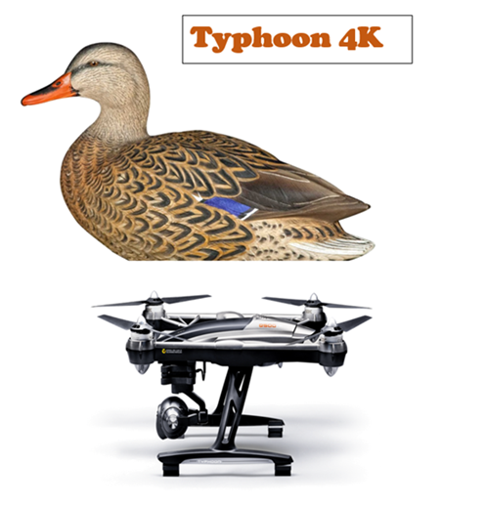

# II. PROBLEM

**Migratory birds, such as geese, ducks and doves, attracted 2.6 million hunters (19%) who spent 23 million days hunting. - doi.gov**

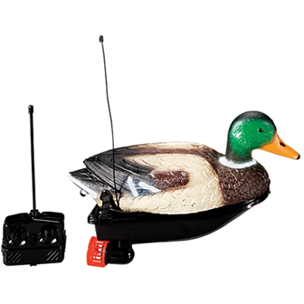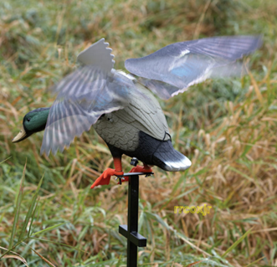 Spending overall $2,648,600,000 on equipment a year? Troubles with not being able to call in flocks of ducks? Maybe having troubles knowing what kind of bird your about to come in contact with? The DeecDRONE is a solution to all of your problems, giving hunters and researchers in the wildlife field a more accurate count of the populations of birds and waterfowl. A product already out there that plays a similar feature in catching the duck flocks eye is a called a Mojo, such as the one in the picture. It is remote controlled with mobile wings and a metal prop to go into the ground. That product has worked well, but is it working enough? They also have water decoys that can float, the one of which that is in the picture has a propeller to look like the duck is swimming.

Whether it swims or looks like its about to land nothing will compare to the fun, effective, new DeecDRONE. Giving Customers the chance to not only make their own but have something that is completely universal for all types of adventures.

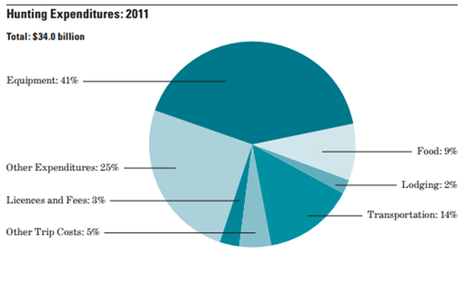Hunters: Hunters spend a lot of money on equipment, licenses, and food with no expectation of money in return, so why not make the expeirence the absolute best it can be and at a resonable price.

Other products only have few features to satisfy your needs while the DeecDRONE can be used in multiple different ways, saving your money. With the competition of mobile Decoys, using DeecDRONE hunters will need fewer Decoys on the ground. The average hunter on one drip depending on geographics uses 1-5 dozen decoys to help call in the birds. With the DeecDRONE hunters will still be able to use the Decoys they do have but only fewer because of the help of the DeecDRONE. Taking hunting to the next level.

Researchers: While Researchers need a quiet approach DeecDRONE will have the latest technology to make it the best upclose experience, it will even match the smell of the birds and mirror the same type of behavior the species portrays.

# III. CUSTOMER SEGMENTS

Primary: Hunters: Males from ages 10-60 years old

Secondary: Women hunters also ages 10-60, wildlife researchers ages 18-60

Business Operations: DeecDRONE will be first sold locally in Ogden Utah. DeecDRONE will be ran through Ogden at the main headquarters and warehouses. It will then be sold in statewide outdoor stores and at hunting expos. It will provide employment for many different areas of work and research.

Additional fixtures for customers- Along with being about to make their own DeecDRONE for those who choose to have a drone with a camera an app will be created to share up close feed from their experiences.

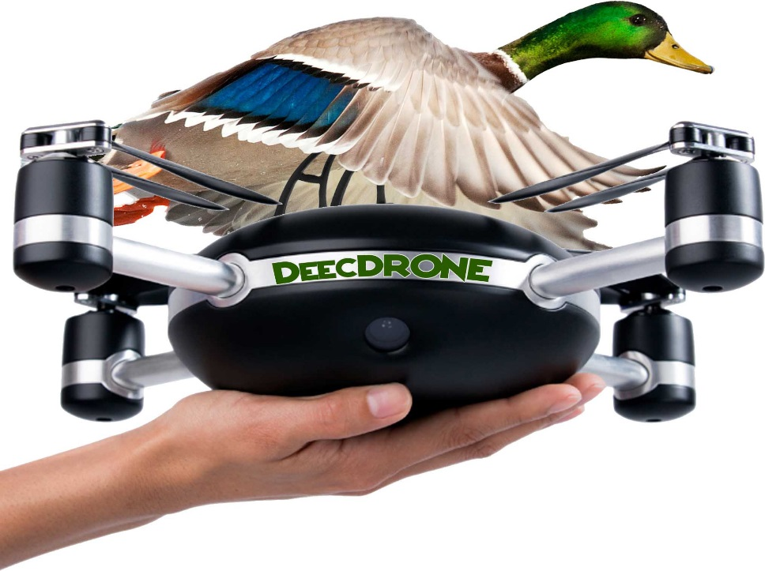

# IV. UNIQUE VALUE PROPOSITION

This will not only be an amazing experience for all but it would solve so many unknown questions people have and it would be a key feature in educating present and future waterfowl hunters on the safety of evaluation. It is beyond unique with its range of differences that could be used for several different occasions and opportunities. Unlike the Mojo discussed above or one that just floats on top of the water, the DeecDRONE will have all different features available to choose from. It would increase the entertainment level found in wildlife and create a better experience all around. With its high technology it will be a famous use in the hunting world helping hunters attract birds. By being amazingly accurate the animals will never know that it’s not real. With the support of DNR Wildlife waterfowl experts it will be the next best thing, allowing for technological growth in the world of hunting, researching, and teaching youth the importance of our wildlife.

# V. SOLUTION

It has amazing potential and will give hunters, educators, researchers, and the everyday people a learning experience that they have never had before. Giving hunters a better chance to meet there limits, Researchers can open new doors to discoveries, and the youth will admire the wildlife more in the next generation.

# VI. CHANNELS

With the calibration from the Drone manufacturers and Material manufacturers the DeecDRONE Warehouse will combine both while going through steps of safety before releasing each individual product.

# VII. REVENUE STREAMS

## Image result for commerce and retail revenue modelREVENUE MODEL

E-Commerce and retail

* E-commerce sales are expected to increase annually by 17%.
* Being that an e-commerce business competes with a Brick and Mortar business, DeecDRONE will have tours for customers in the main Ogden Warehouse to see the process up close.

## REVENUE

The revenue for this product will be based on products sold. The projected revenue for ten basic completed products would be $4,000; for the kits it would be $5,000. Being that they are more pricy they’ll have the best quality possible. DeecDRONE’s projected revenue will be matched and the profit will be bigger.

## Projected sales – one year

The gross margin measured per year for both individual products and kits is $240,000.

# VIII. COST STRUCTURE

## Customer acquisition costs

A duck decoy is a man-made object resembling a real duck. Duck decoys are sometimes used in duck hunting to attract real ducks. Duck decoys were historically carved from wood, often cedar wood on the east coast from Maine to South Carolina, or cork. Modern ones may also be made of canvas and plastic. They are usually painted, often elaborately and very accurately, to resemble various kinds of waterfowl. A typical 6 or 12 pack of waterfowl Decoys costs from $40-$200 in other stores.

## Distribution costs

Being that DeecDRONE pays for the distribution from the drone and material manufacturers it will be made up by outdoor stores, expos and the customer shipping. They will balance out one another.

## Human resource costs

* Hiring
* Performance management and reviews
* Employee development, motivation, and training
* Safety and wellness
* Benefits
* Communication between employees and/or management

HR carries a big responsibility. They have a huge effect on the culture and environment in the workplace, setting the tone for how employees communicate, settle disputes, and work with each other. Some small businesses prefer to [outsource a large component of human resources](http://www.inc.com/fiscal-times/human-resources-big-savings-for-small-business.html), but there is no getting around human resources completely.

## PROJECTED EXPENSES



# IX. KEY METRICS

In order for smooth running many metrics will be run daily including accounts payable, accounts receivable, recurring revenue, projected profit, lifetime value, an income analysis, and customer satisfaction. Also all testing and licensing for each individual project that will be leaving the warehouse.

# X. COMPETITIVE ADVANTAGE

Since this is a very rare product and technically invisible no one else will be able to compete with the low prices and accuracy of appearance. Where DeecDRONE is the first of its kind they will be ahead on all advancements in technology and be able to try it out first in the market.

# XI. CONCLUSION

The DeecDRONE is projected to create a $500,000 revenue in its first year and would create over 500 jobs each year as well. The DeecDRONE will be the first of its kind and there is no other product like it. Combing a Decoy or a replication of any bird and any style drone you could have your own research project. There will be an app made to share videos from all types of experiences. This will take hunting to the next level and give answers to any unknown questions. The world makes advancements every day in every aspect of life, the DeecDRONE will be one of the biggest in the history of hunting yet to come.

# XII. BIBLIOGRAPHY

<http://www.fieldandstream.com/node/1005010520>

<http://myfirstdrone.com/tutorials/buying-guides/best-drones-for-sale/#camera_drones_index>

<http://www.nativetech.org/decoy/DUCKDECOYS.htm>

<http://gizmodo.com/some-good-things-drones-can-actually-do-1475717696>

<http://www.sciencekids.co.nz/sciencefacts/animals/bird.html>

<https://www.doi.gov/sites/doi.gov/files/migrated/news/pressreleases/upload/FWS-National-Preliminary-Report-2011.pdf>

<https://wildlife.utah.gov/hunting-in-utah/hunting-information/waterfowl.html>

<http://articles.bplans.com/7-key-metrics-every-business-owner-monitor/>

<https://wheniwork.com/blog/what-is-human-resources/>

<https://www.entrepreneur.com/encyclopedia/operating-expenses>

# XIII. APPENDIX

Here are some fun facts:

• Birds have feathers, wings, lay eggs and are warm blooded.

• There are around 10,000 different species of birds worldwide.

• The Ostrich is the largest bird in the world. It also lays the largest eggs and has the fastest maximum running speed (97 kph).

• Scientists believe that birds evolved from theropodous dinosaurs.

• Birds have hollow bones which help them fly.

• Some bird species are intelligent enough to create and use tools.

• The chicken is the most common species of bird found in the world.

• Kiwis are endangered, flightless birds that live in New Zealand. They lay the largest eggs relative to their body size of any bird in the world.

• Hummingbirds can fly backwards.

• The Bee Hummingbird is the smallest living bird in the world, with a length of just 5 cm (2 in).

• Around 20% of bird species migrate long distances every year.

• Homing pigeons are bred to find their way home from long distances away and have been used for thousands of years to carry messages.